**Model Development Phase**

|  |  |
| --- | --- |
| Date | 6 July 2025 |
| Team ID | SWTID1749821186 |
| Project Title | Enhancing Product Reliability: Leveraging Transfer Learning for Fault Detection |
| Maximum Marks | 10 Marks |

**Initial Model Training Code, Model Validation and Evaluation Report**

**Initial Model Training Code:**

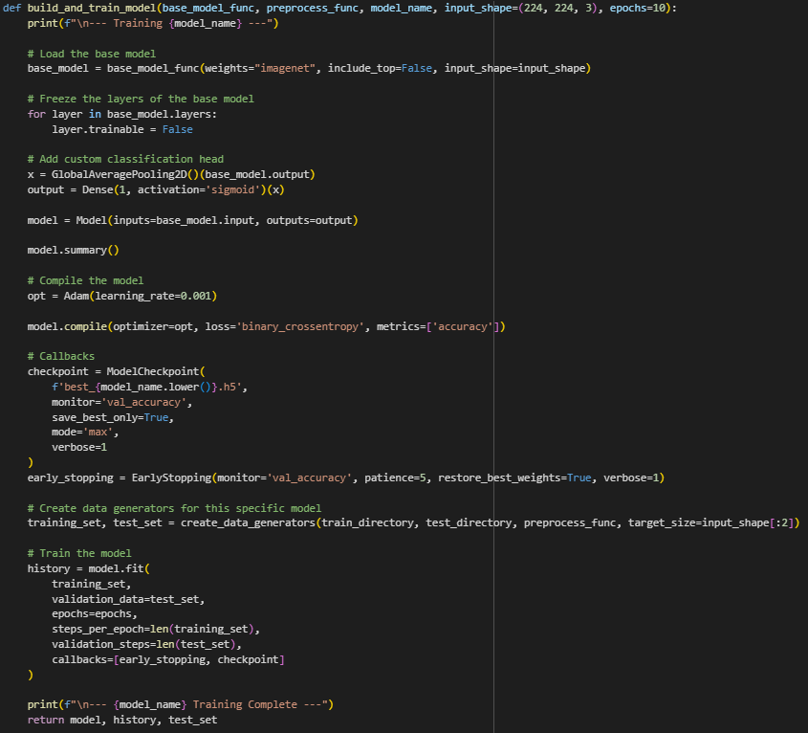

**Model Validation and Evaluation Report:**

|  |  |  |
| --- | --- | --- |
| **Model** | **Summary** | **Training and Validation Performance Metrics** |
| VGG16 |  |  |
| Inceptionv3 |  |  |
| Resnet50 |  |  |